MATHEMATICS REVISION PAPER-1 Duration: 1 hr

1. Mental Maths: [20 x 1 = 20]

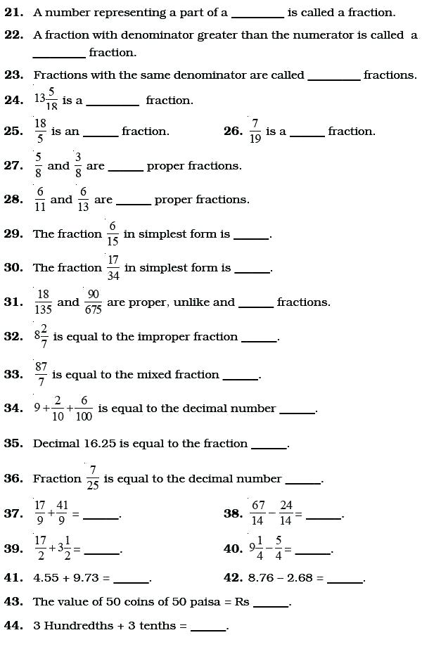

1. Solve:- [3 x 4 = 12]
2. Joshua jogged 4 $\frac{3}{8}$ km altogether. He jogged 1 $\frac{1}{2}$ km in the morning, $\frac{5}{8}$ km in the afternoon and the rest of the distance in the evening. How far did he jog in the evening?
3. Shelly had 14 kg of peanuts. She sold $\frac{5}{7}$ of them. Find the amount of peanuts she had left.

3. Sam received $150 of pocket money. He spent $\frac{2}{5}$ of it on a pair of shoes and $\frac{1}{6}$ of the remaining on a watch.

a. How much did the shoes cost?

b. Find the sum of money he had left in the end?

c. What fraction of his pocket money had he left?

III. Solve:- [3 x 3 =9]

1. 4/7 of a number is 84. Find the number.
2. 5 $\frac{1}{7}$ − { 3 $\frac{3}{10}$ ÷ ( 2 $\frac{4}{5}$ − $\frac{7}{10}$)}
3. 4 $\frac{4}{5}$ ÷ { 2 $\frac{1}{5}$- $\frac{1}{2}$ ( 1 $\frac{1}{4}$- $\frac{1}{4}$- $\frac{1}{5}$) }